# Working with the DS Family Command in PowerShell

Table of Contents

Working with the DS Family Command in PowerShell 1

Objectives 3

**1. Commands Description** 3

2. Tasks 4

**•** **Creating Sub-OUs:** I focused on the Sales OU, and I added two nested OUs (Sub-OUs) 6

**•** Deleting unwanted OU 8

**•** Renaming and Moving OUs 9

**3. Creating Security Groups** 12

**3.1 Creating Groups** 12

**4** **Moving and Renaming the groups created** 16

**5** **Creating Computer objects** 19

**6** **Removing a Subtree (Branch of an Active Directory Structure)** 21

**7** **Creating User Object** 22

**Conclusion** 23

## **Objectives**

This lab aimed at demonstrating my understanding of the “ds” family command through different steps. It is worth noting that the commands are not case sensitive. The hands-on lab focused on creating Organizational Units (OUs), Computers, and Users Objects.

### **1. Commands Description**

* Dsquery/dsquery: This was used to display a query for requesting information. It allowed the search on Active Directory about objects, namely, Users, Computers, groups, contacts, and OUs.
* Dsadd/dsadd: This was used to add users, computers, OUs, Contacts, and groups to the Active Directory.
* Dsget/dsget: This was used to display the properties (properties search) of the Active Directory, namely, Users, Computers, OUs, Contacts, groups, sites, subnet, servers (DC), quotas, and partitions.
* Dsmove/dsmove: This was used to rename or move an Active Directory Object
* Dsrm/drsm: This was used to remove a single object/branch (subtree) of an Active Directory.
* Dsmod/dsmod: This was used to modify the properties of an Active Directory.

## 2. Tasks

* Creating OU named “Sales” using the command: dsadd ou “ou=Sales,DC=Urim,DC=org” -desc “Sales Organizational Unit”

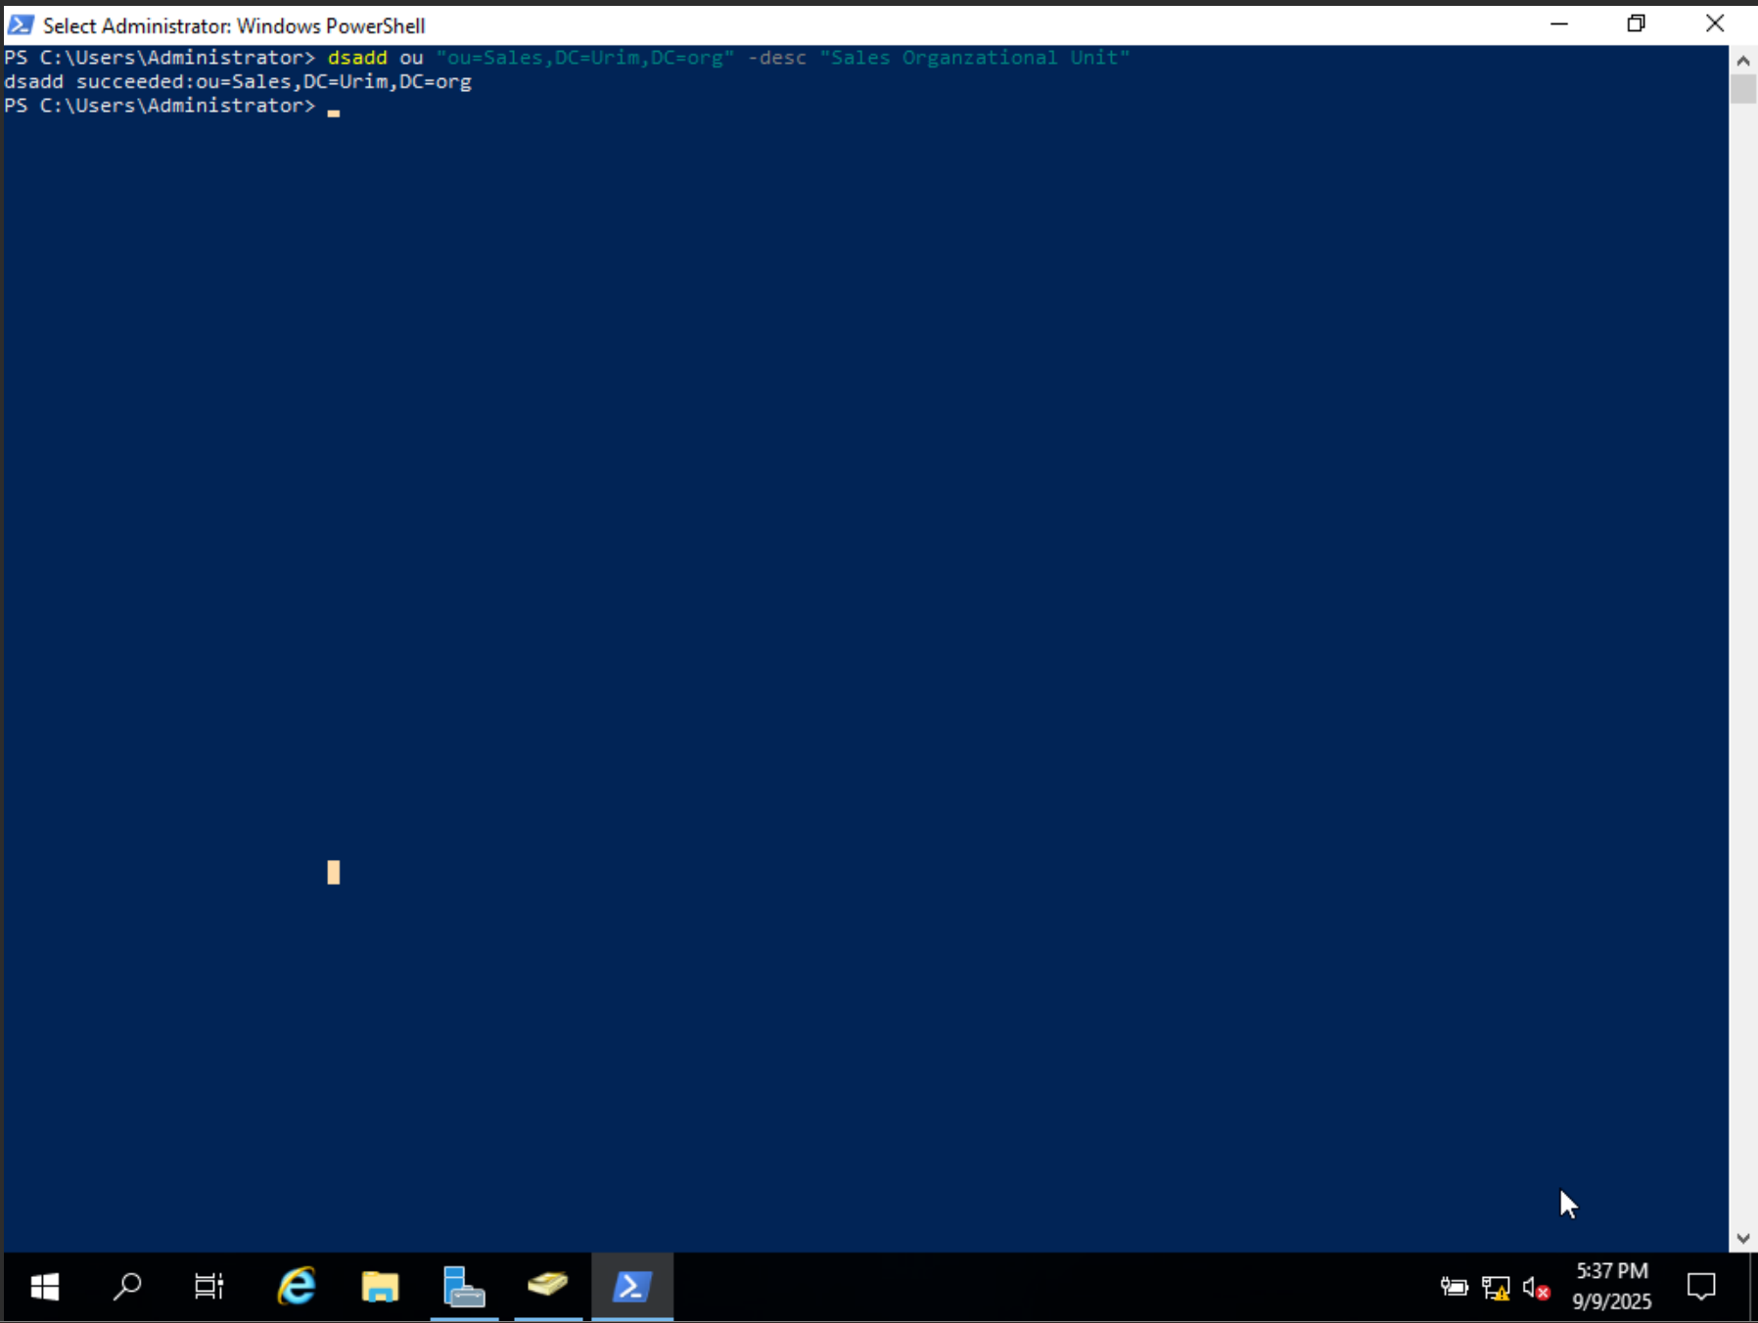

Figure 1: Sales OU (source: personal collection)

* Displaying query information: I used the command “dsquery ou” as follows:

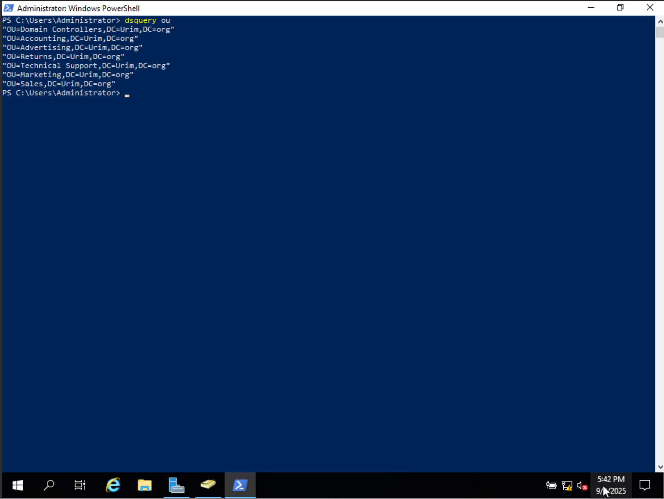

Figure 2: Dsquery in action (source: personal collection)

The query information displayed additional OUs to the one created in the previous task.

### **Creating Sub-OUs:** I focused on the Sales OU, and I added two nested OUs (Sub-OUs) using the command” dsadd ou “ou=Nairobi Sales, ou=Sales,DC=Urim,DC=org” and dsadd ou “ou=Nakuru Sales,ou=Sales,DC=Urim,DC=org” as follows:

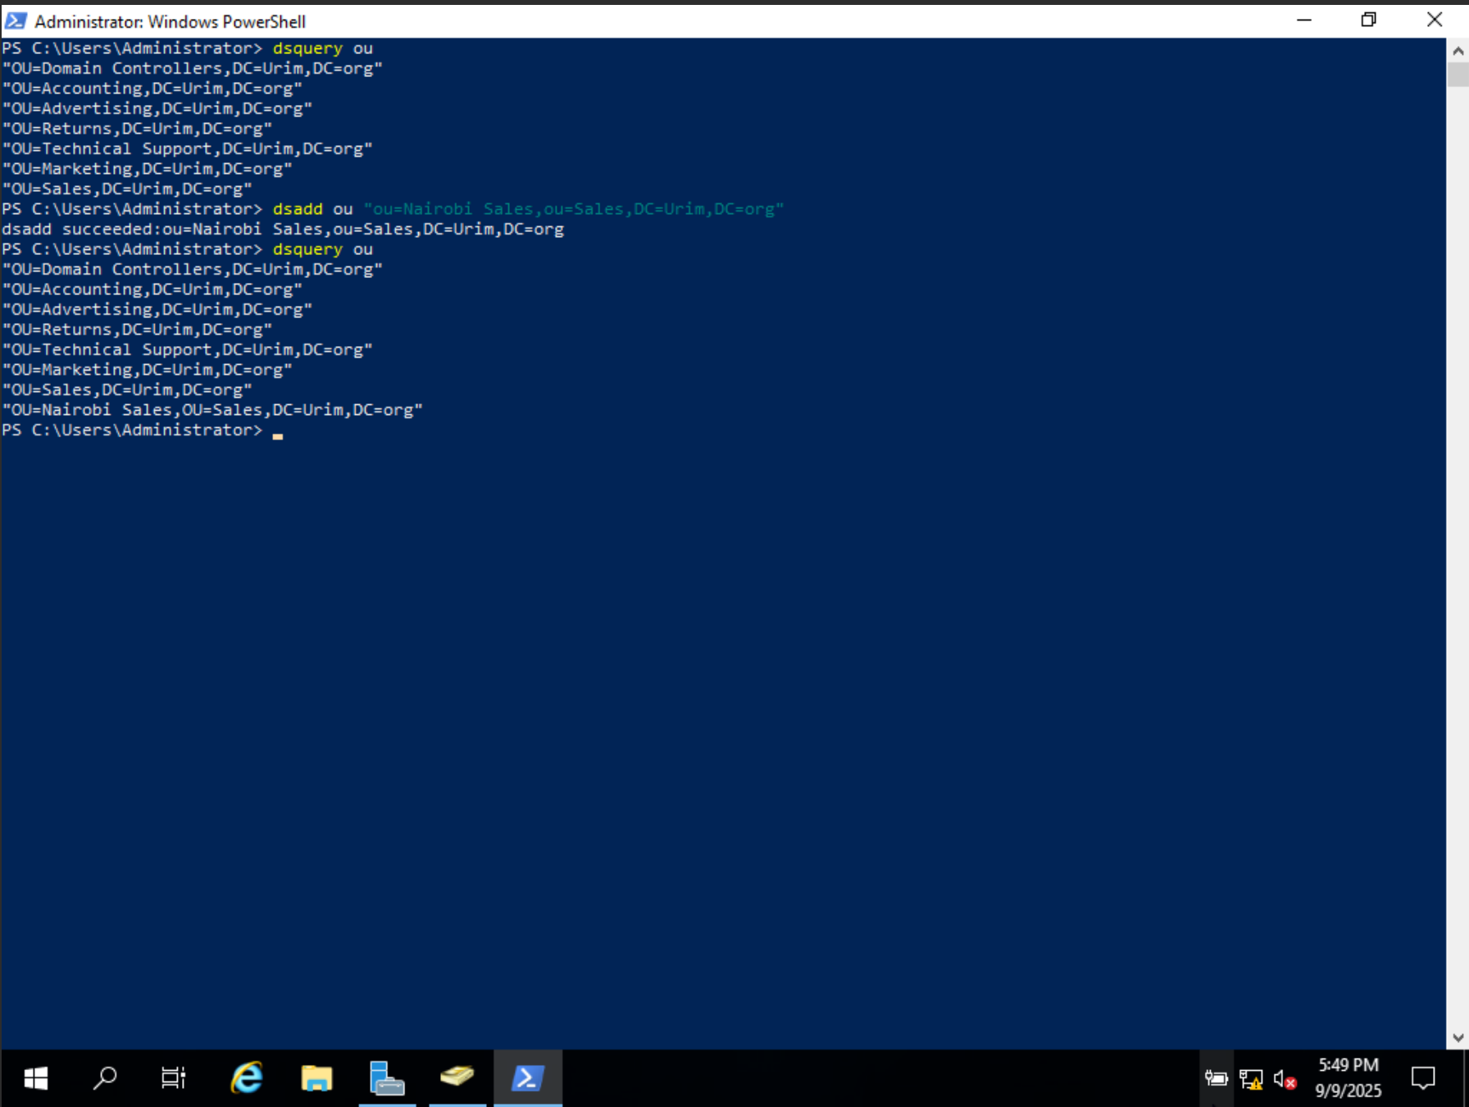

Figure 3: Nairobi Sales OU (source: personal collection)

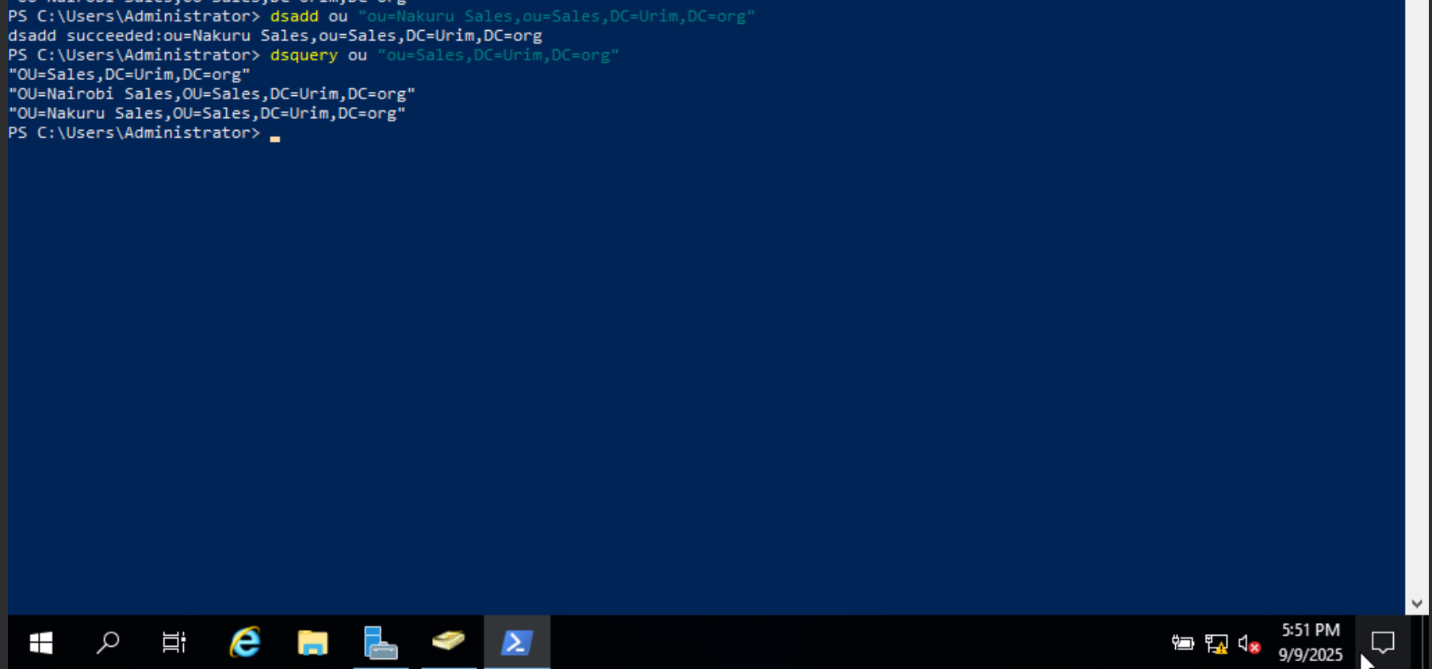Figure 4: Nakuru Sales OU (source: personal collection)

* Deleting unwanted OU: I used the command dsrm “ou=Stuff,DC=Urim,DC=org” as follows:

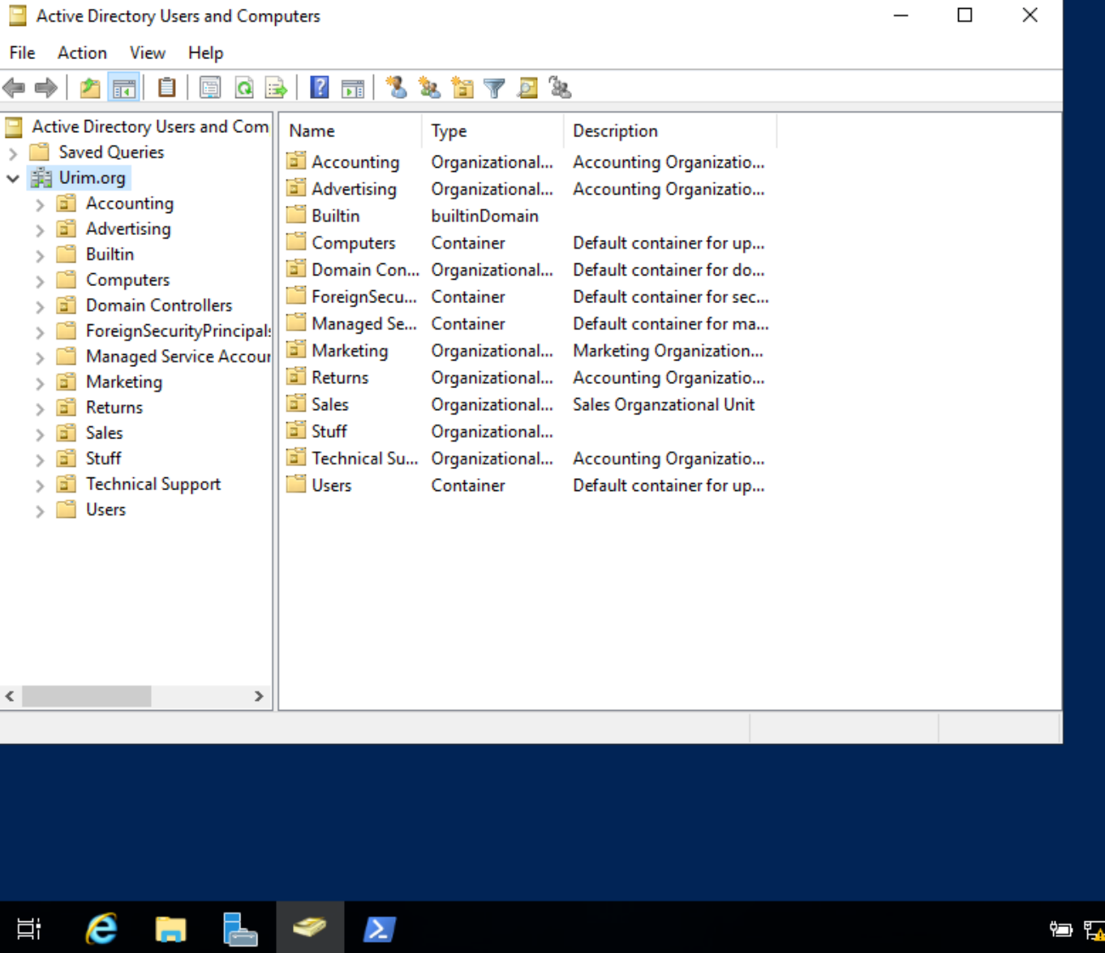

Figure 5: Stuff OU before deletion (source: personal collection)

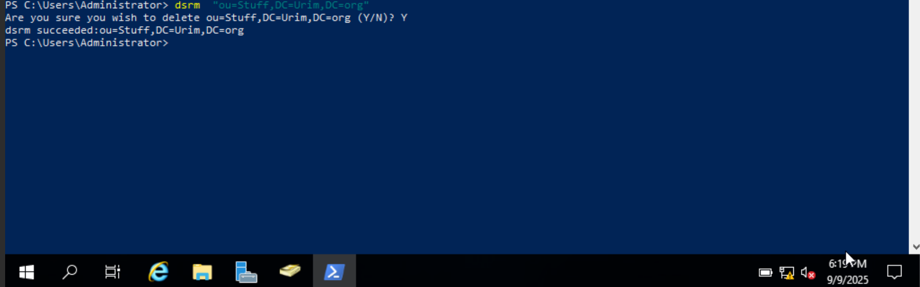Figure 6: Removing Stuff OU (source: personal collection)

### Renaming and Moving OUs

**Things to remember:**

* Use dsmove to rename or move objects in Active Directory.
* Copying (cloning) objects creates a new instance in the same or a different location.
* Renaming an object keeps it in the same location and requires specifying its path (OU, DC).
* When you move an object, it changes location. You need to provide both its current path and the new path.

**Tasks**

1. Renaming the OU Sales to My Sales: I used the command dsmove “ou=Sales,DC=Urim,DC=org” -newname “My Sales” as follows:

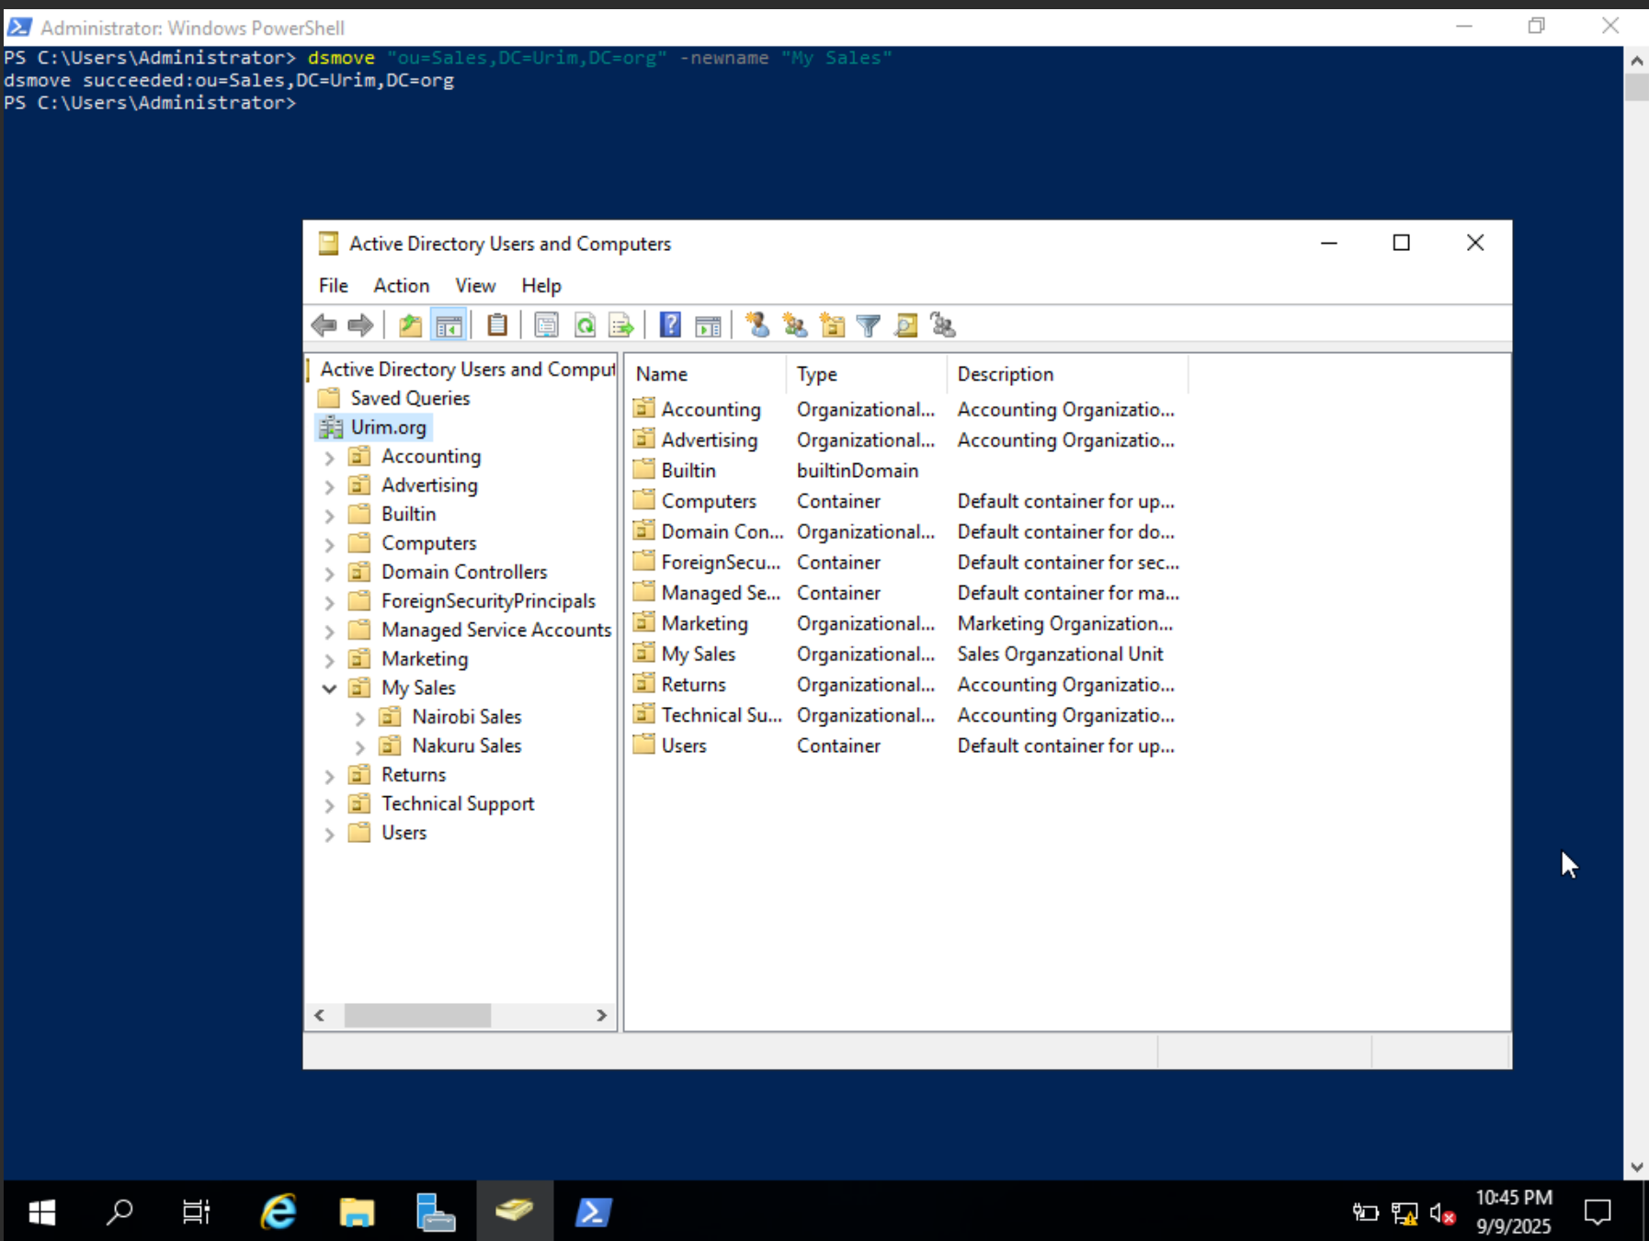Figure 7: PowerShell and ADUC display (source: personal collection)

1. Move the Nairobi Sales OU to the Marketing OU and rename it Nairobi Marketing:

I used the command dsmove “ou=Nairobi Sales, ou=My Sales,DC=Urim,DC=org” -newname “Miami Marketing” -newparent “ou=Marketing,DC=Urim,DC=org” as follows:

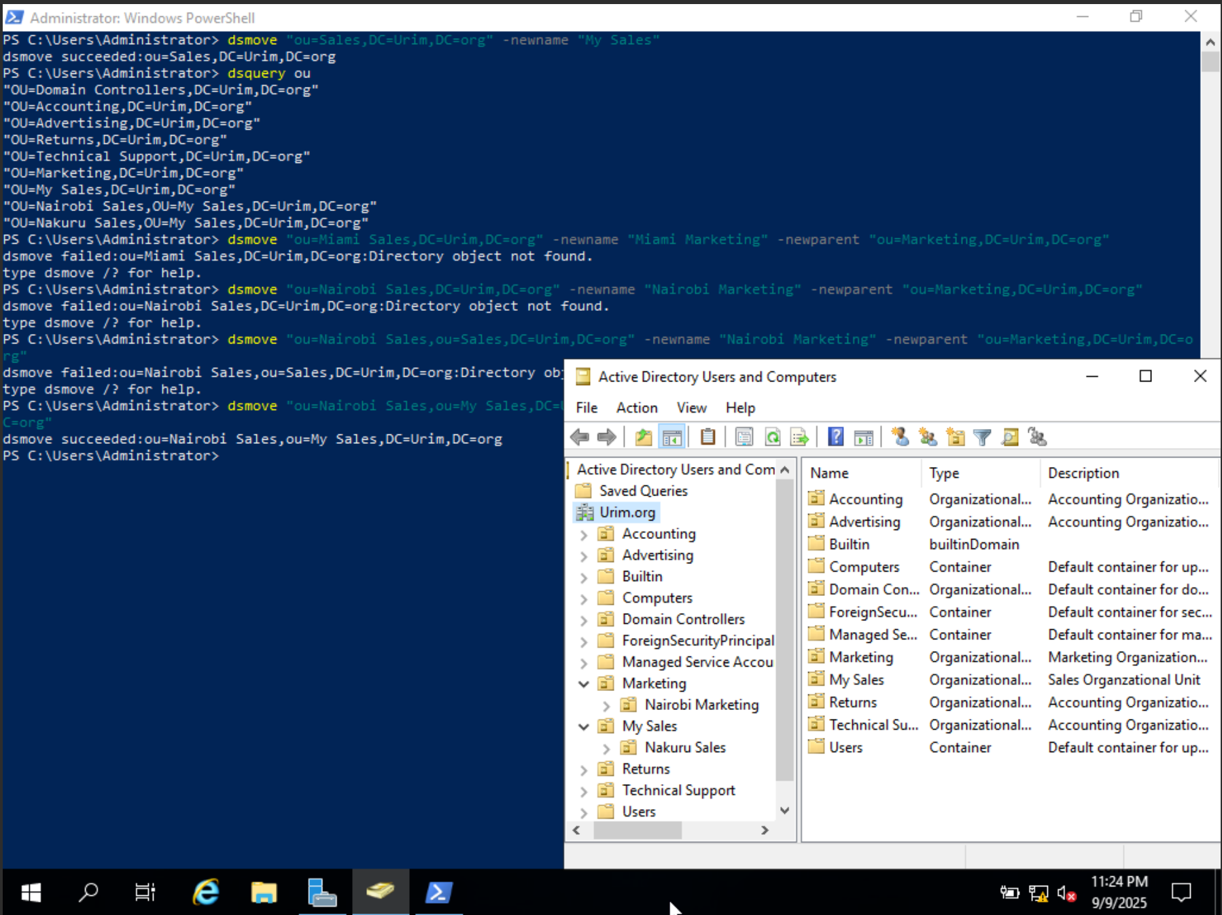

Figure 8: Moving Nairobi Sales to the Marketing OU (source: personal collection)

### **3. Creating Security Groups**

### **3.1 Creating Groups**

* I created security groups by using the syntax: dsadd group “CN=name,OU=name,DC=Name,DC=domain” -secgrp yes
* I then created a Sales Security Group in the OU as follows: dsadd group “CN=Sales,OU=Sales,DC=Urim,DC=org” -secgrp yes

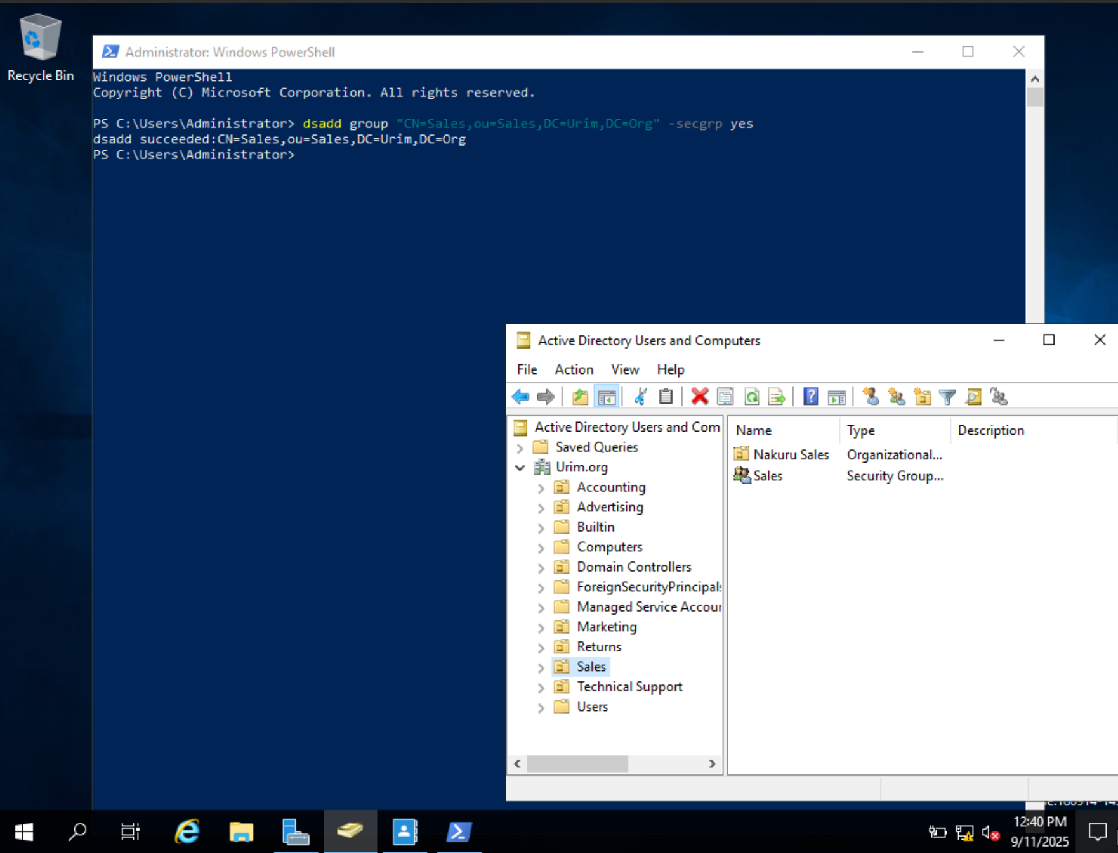

Figure 9: Sales group overview (source: personal collection)

* Next up, was the Sales Managers group created as follows: dsadd group “CN=Sales Managers,OU=Sales,DC=Urim,DC=Org” -secgrp yes

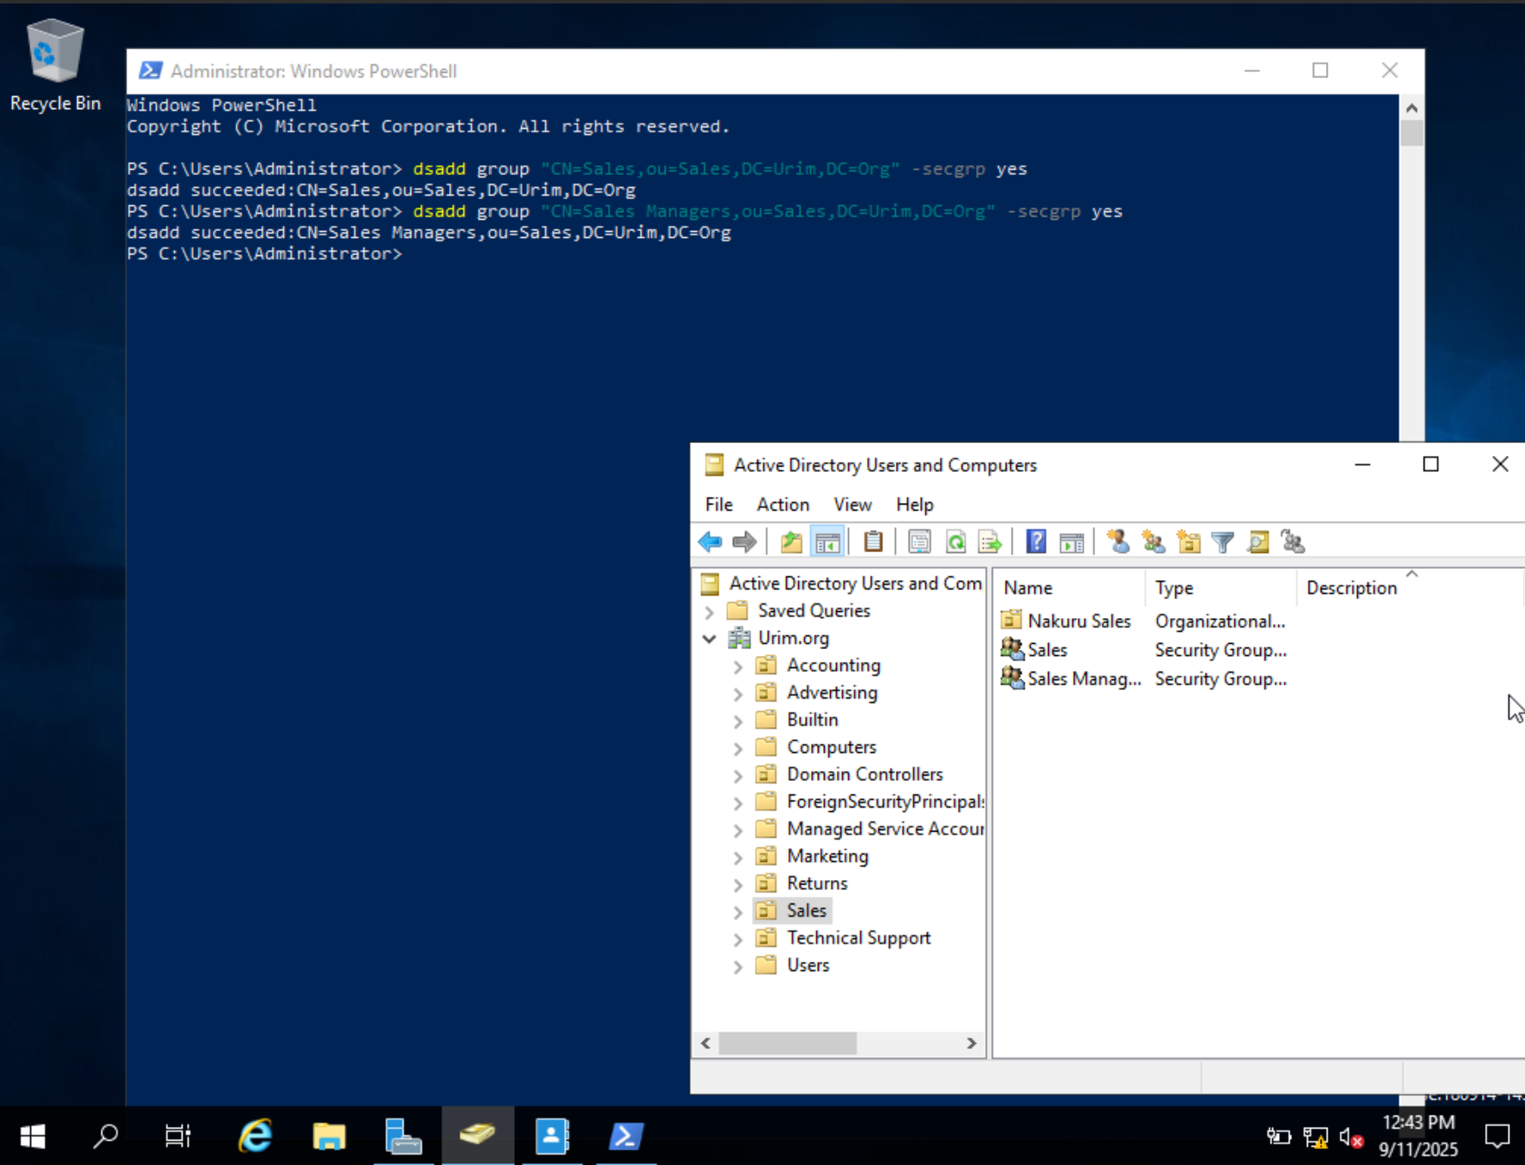

Figure 10: Sales Managers group overview (source: personal collection)

* Lastly, I created the Finance group inside the Finance OU as follows: dsadd group “CN=Finance Group, ou=Finance,DC=Urim,DC=Org” -secgrp yes

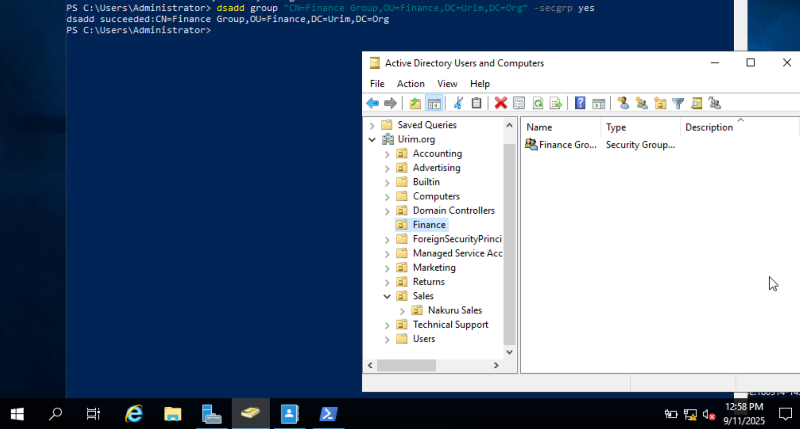

Figure 11: Finance Group (source: personal collection)

* 1. **Verification**

I used the syntax dsquery group “OU=Name,DC=Name,DC=Domain” as follows:

* Verifying groups created inside the Sales OU: dsquery group “ou=Sales,DC=Urim,DC=Org”
* Verifying groups created inside the Finance OU: dsquery group “ou=Finance,DC=Urim,DC=Org”
* Note: the syntax dsquery group, displays all groups in the domain.

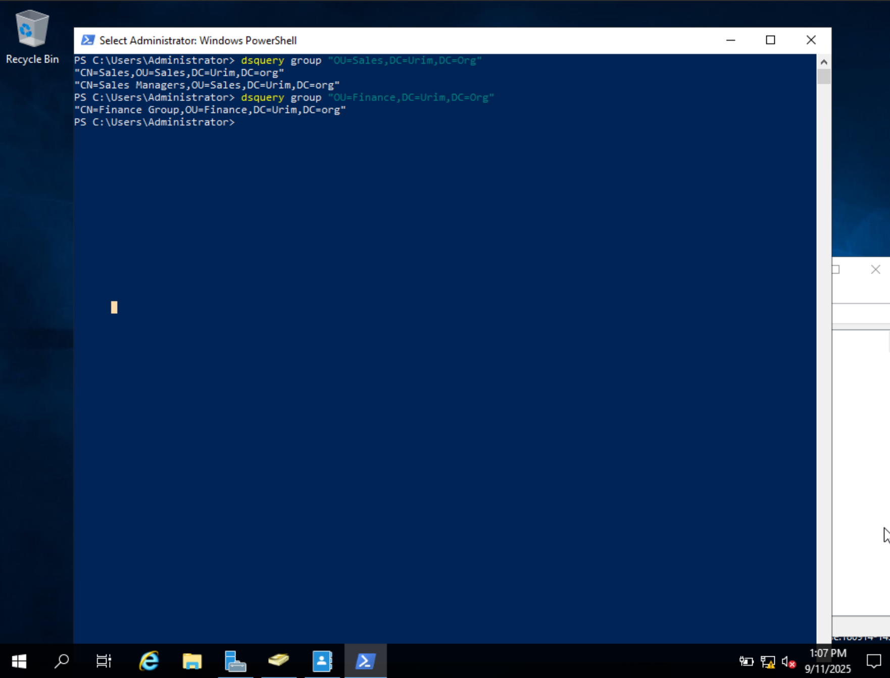

Figure 12: Query info about groups created (source: personal collection)

### **Moving and Renaming the groups created**

**Task 1: renaming the Finance OU to Research & Development**

I used the command: dsmove “OU=Finance,DC=Urim,DC=Org” -newname “Research & Development” as follows:

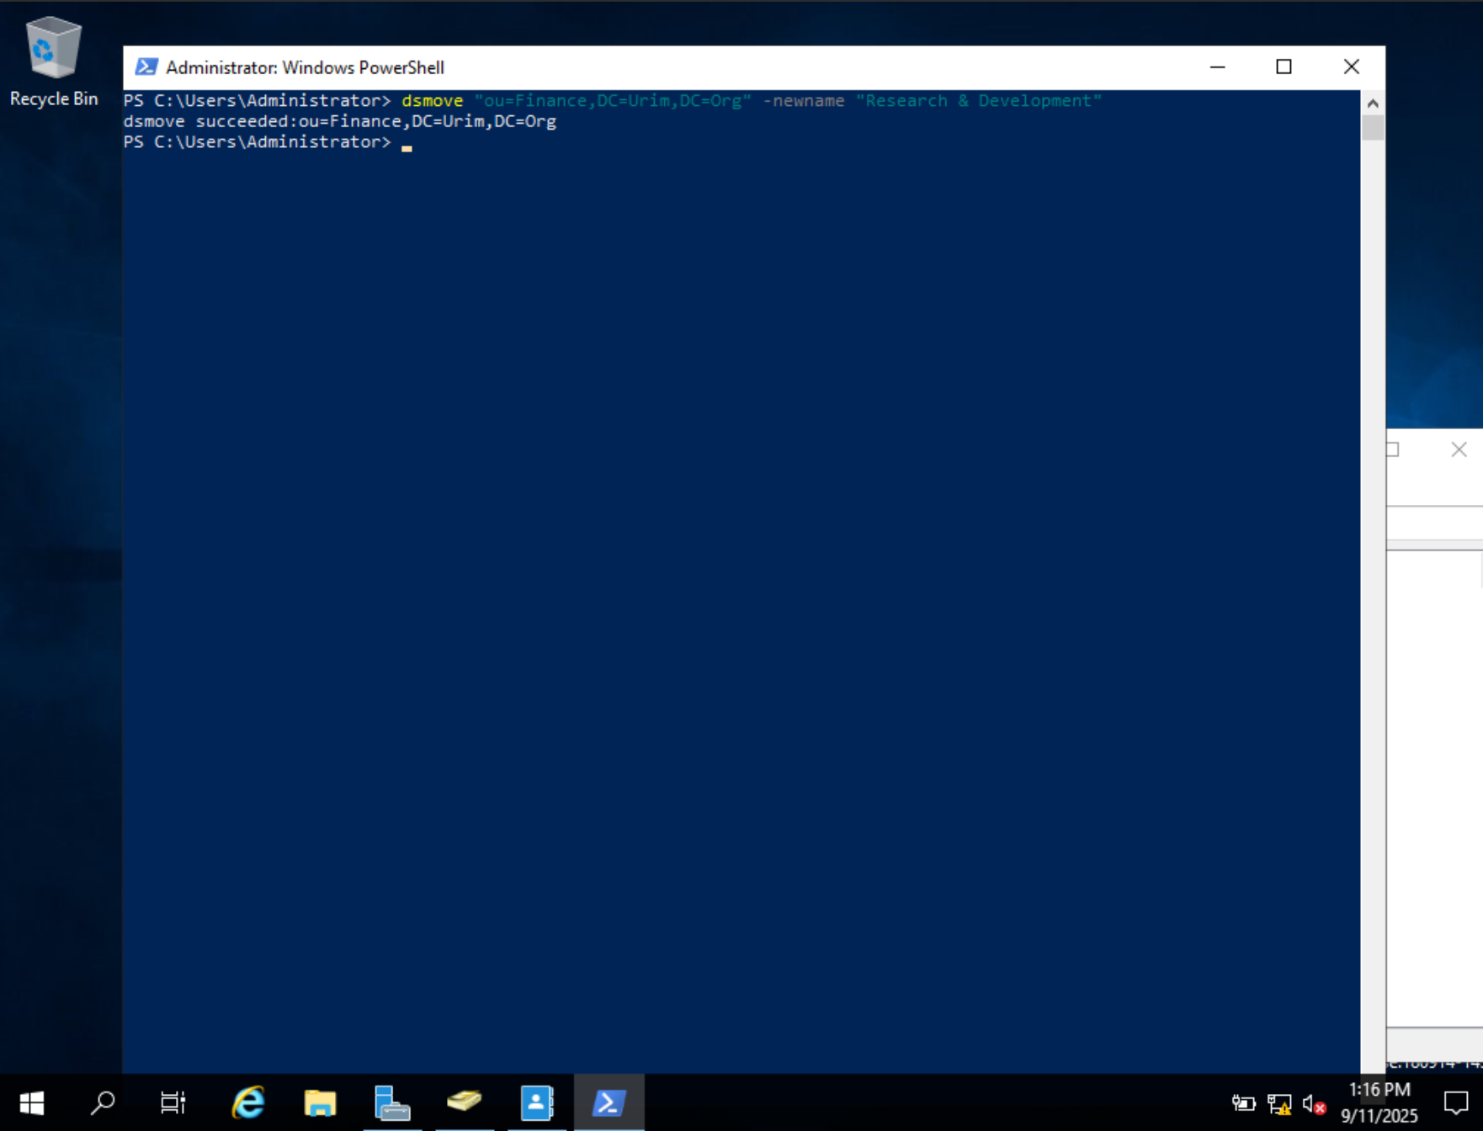

Figure 13: R&D creation (source: personal collection)

**Task 2: Renaming the Finance group to R&D group**

I used the command: dsmove “CN=Finance Group,OU=Research & Development,DC=Urim,DC=Org” -newname “R&D Group”

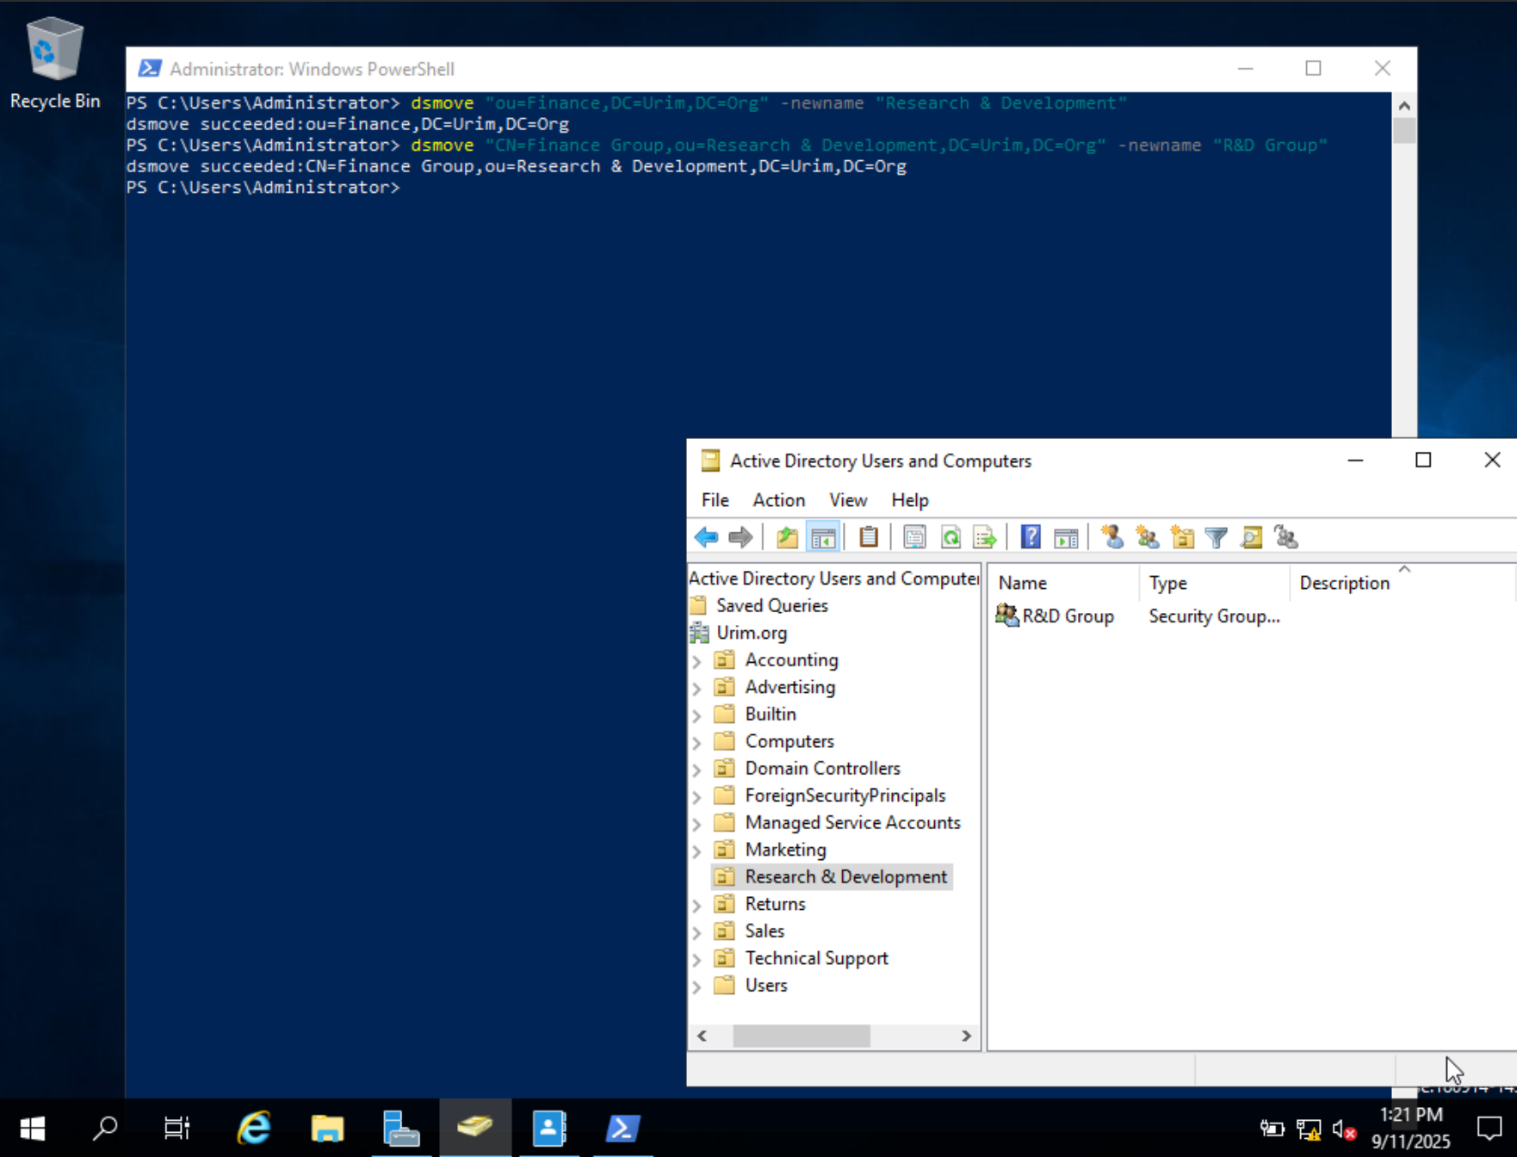

Figure 14: R&D group (source: personal collection)

**Task 3: Transferring the Sales Managers Group from the Sales Organizational Unit (OU) to the Research and Development OU. Simultaneously, rename the group to Research Managers.**

I used the command: dsmove “CN=Sales Managers,ou=Sales,DC=Urim,DC=Org” -newname “Research Managers” -newparent “OU=Research and Development,DC=Urim,DC=Org”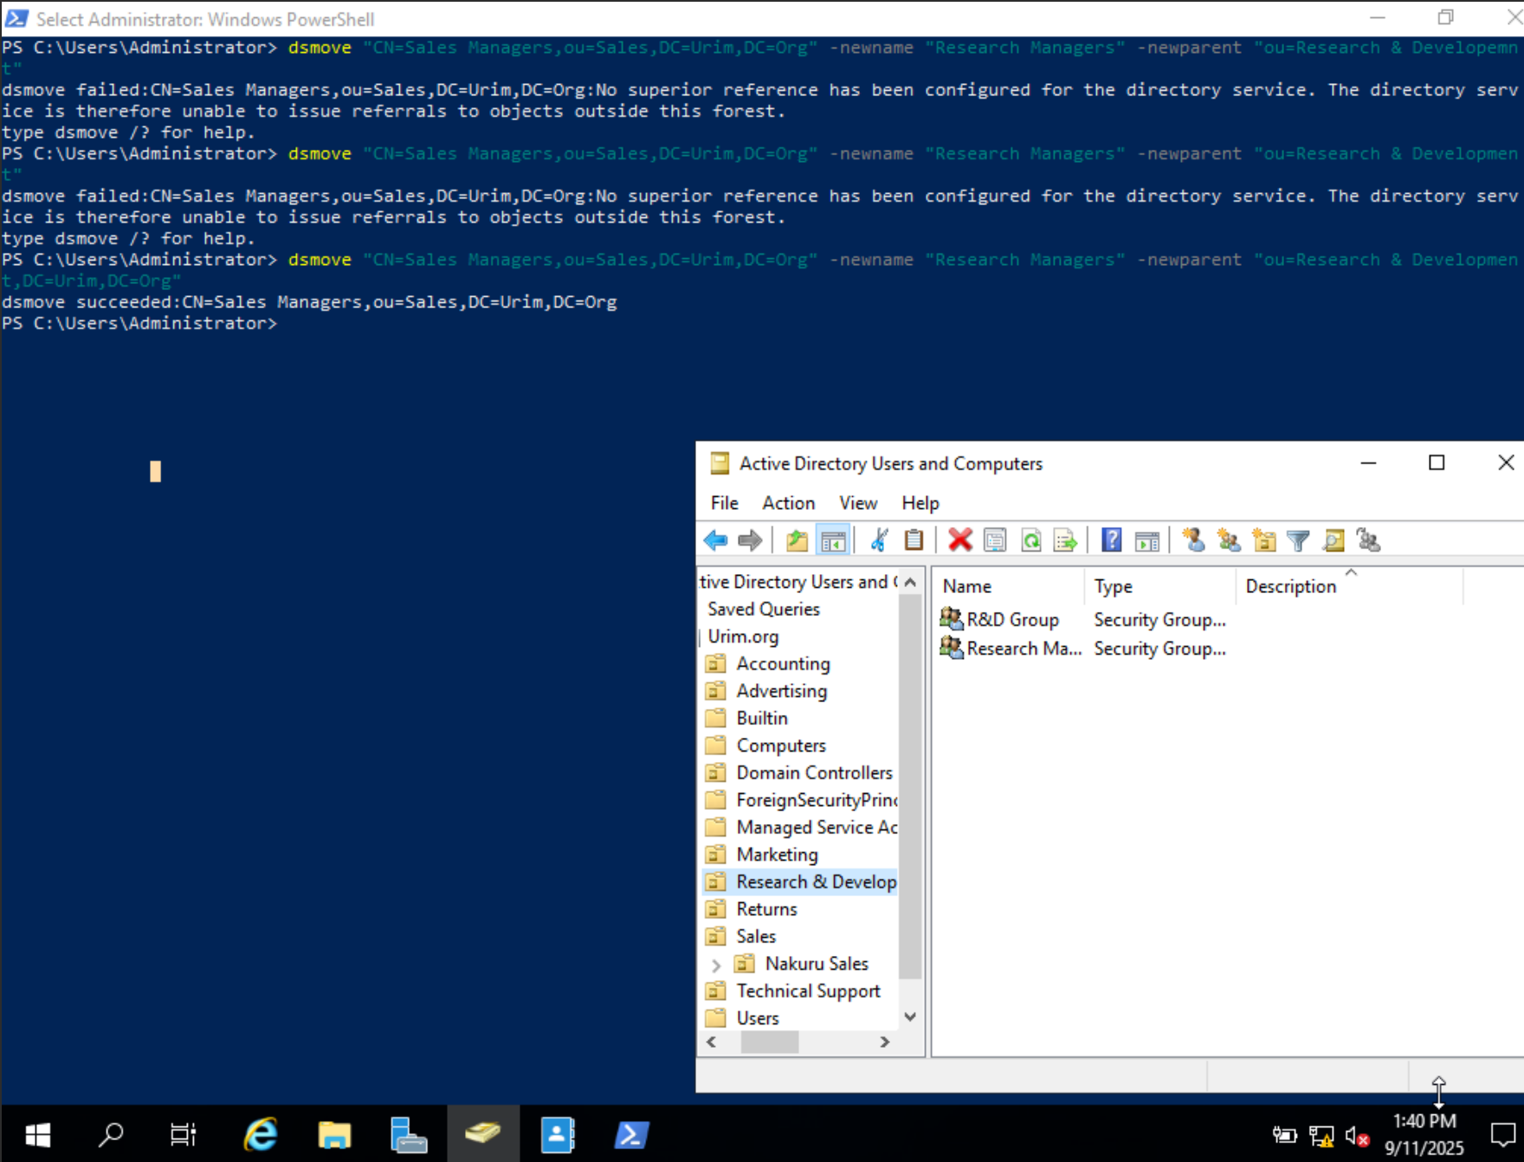

Figure 15: Research Managers group (source: personal collection)

### **Creating Computer objects**

I used the syntax dsadd computer <DN> as follows:

**Task 1: creating computer objects inside the Advertising OU:** dsadd computer “CN=Win11WKS21,OU=Advertising,DC=Urim,DC=Org”

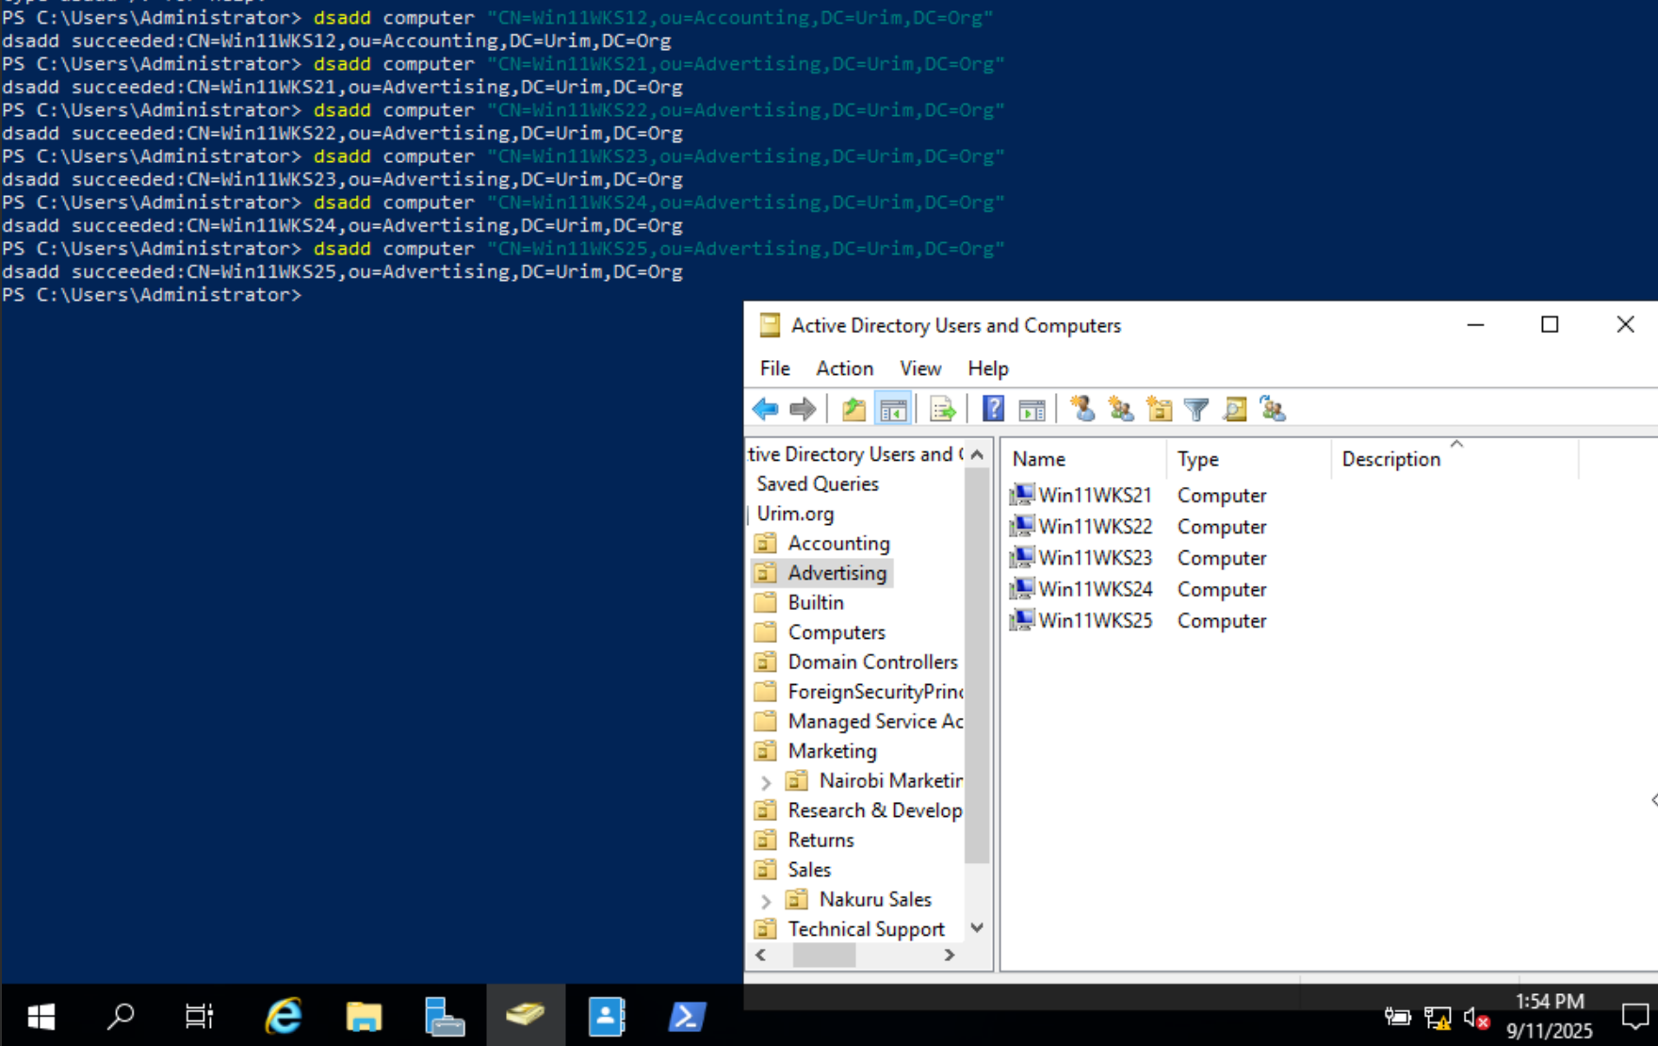

Figure 16: Advertising OU Computers (source: personal collection)

**Task 2: Deleting the computer object**

I used the command: dsrm “CN=Win11WKS24,ou=Advertising,DC=Urim,DC=Org” as follows:

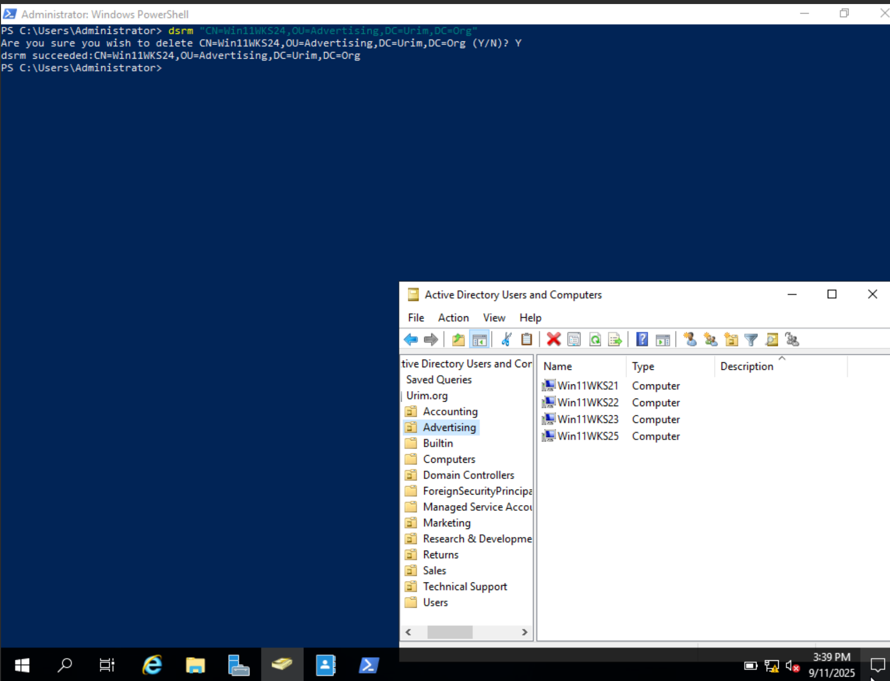

Figure 17: Removing Win11WKS24 from Advertising OU (source: personal collection)

### **Removing a Subtree (Branch of an Active Directory Structure)**

I used the syntax dsrm -subtree -noprompt <DN of the object> as follows:

Task 1: Removing the Marketing subtree : I used the command dsrm -subtree -noprompt “ou=Marketing,DC=Urim,DC=Org”

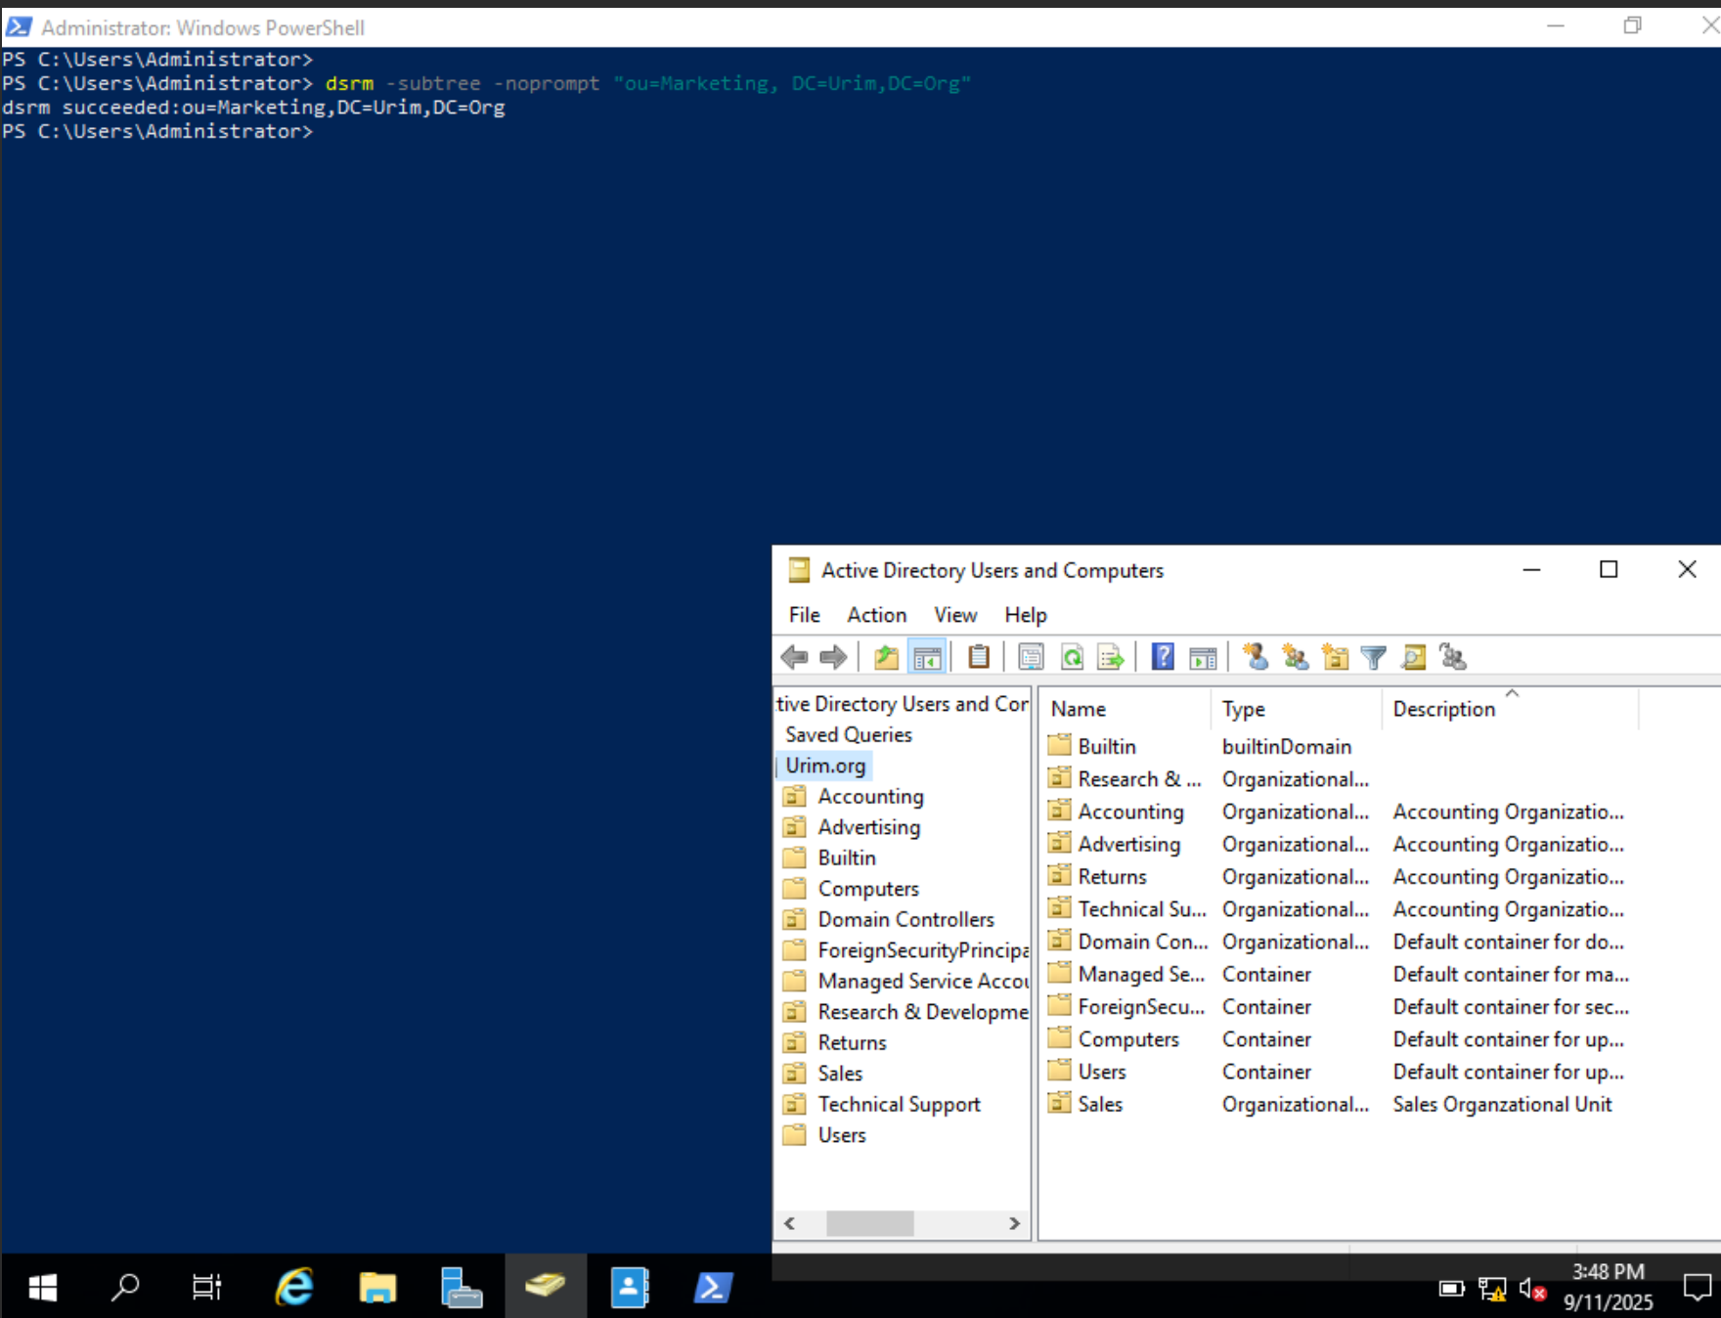

Figure 18: Marketing Subtree deletion (source: personal collection)

### **Creating User Object**

**Task 1: Creating a user object Peter Parker, with properties as follows:**

Dsadd user “CN=Peter Parker,OU=Sales,DC=Urim,DC=Org” -disabled no -memberof “CN=Sales,ou=Sales,DC=Urim,DC=Org” -pwd Secret123 -upn [pparker@Urim.org](mailto:pparker@Urim.org) -samid pparker

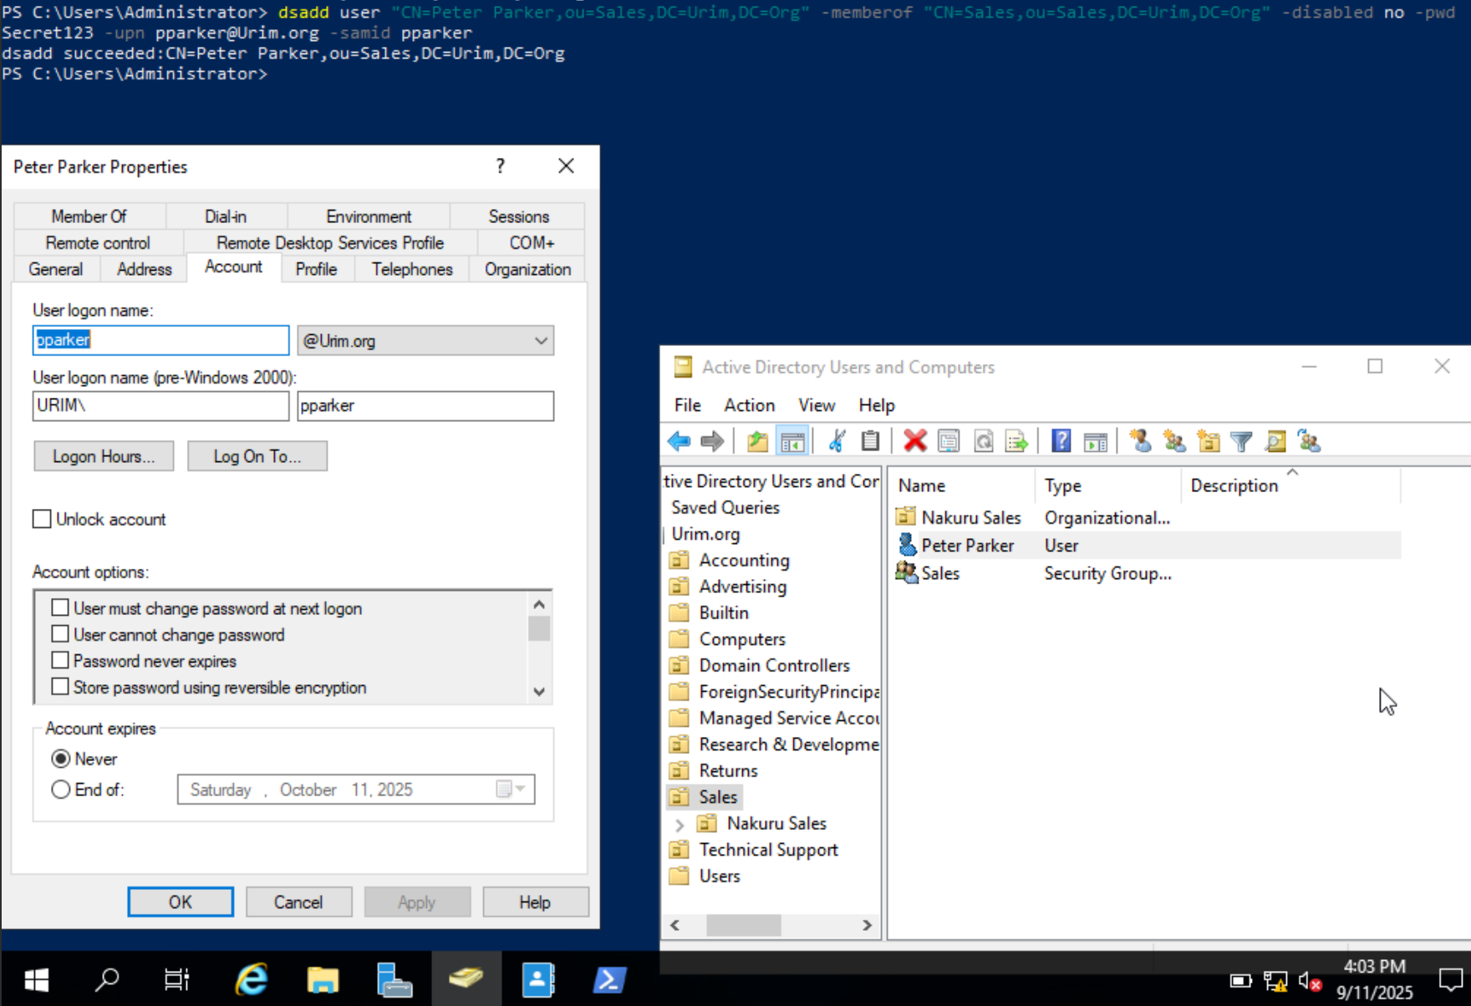

Figure 19: User object creation (source: personal collection)

### **Conclusion**

In this lab, I showed what I learned about the 'ds' family of commands by working through several steps. I also found out that the commands work the same way whether you use uppercase or lowercase letters. During the lab, I practiced creating Organizational Units, Computers, Users, and Database Objects.

I learned the value of automation through PowerShell commands. Using those commands made work easier and faster at the same time. I am looking forward to applying this in real real-world scenario.